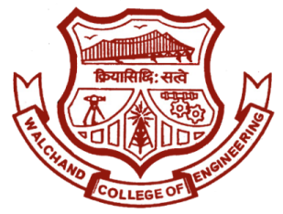

WALCHAND COLLEGE OF ENGINEERING, SANGLI

**ELESA**

**ELECTRONICS ENGINEERING STUDENTS’ ASSOCIATION**

Date:

To,

The CCF In charge,

WCE Sangli.

Sub: About displaying event name on login page of college wifi.

Respected sir,

On 9th and 10th September 2017, Electronics Engineering Students’ Association of Walchand College of Engineering, Sangli is organizing a two day technical mega event **‘ELECTROVERT’** in the college.

**ELECTROVERT** comprises of many different engineering fields. It will surely help the students in not only developing their technical skills, but also in dynamically shaping their personalities.

We request you to post our event name on the login page of college wifi.

The text to be shown:

ELESA presents ELECTROVERT 2017…Performers creed….on 9th and 10th September for more details **click here.**

Website: www.elesa.in

Thanking you,

Email: [walchand.elesa@gmail.com](mailto:walchand.elesa@gmail.com) Website: [www.elesa.in](http://www.elesa.in)

Dr. B. G. Patil

H.O.D.,

Dept. Of Electronics

Dr. S.D. Ruikar

Staff Advisor,

ELESA

Mr. Mahadev Mishal

Secretary,

ELESA

**HOD,**

**Dept. Of Electronics**

Dr. B. G. Patil

**Staff Advisor**

Dr. S. D. Ruikar

**President**

Shubham Mhatre

**Vice-President**

Pooja Arekar

**Event Director**

Amit Patil

Raunak Suryawanshi

**Technical Director**

Sunita Patil

Raghunandan Kangule

**Club Service Director**

Swaroopa Ingale

**Aptitude Developer**

Shantanu Vipradas

Arati Balekundri

**Editor**

Pratik Thepale

**Web Developer**

Prafull Mahajan

Rushikant Birajdar

**Treasurer**

Hrishikesh Nikam

**Digital Publicity Head**

Revati Shiudkar

Shivam Aware